

**Customer Retention Dataset**

Submitted by:

**SHEFALI MEVADA**

**ACKNOWLEDGMENT**

**E-retail factors for customer activation and retention:**

This is a Case study from Indian E-Commerce customers.

Customer satisfaction has emerged as one of the most important factors that guarantee the success of online store; it has been posited as a key stimulant of purchase, repurchase intentions and customer loyalty. A comprehensive review of the literature, theories and models have been carried out to propose the models for customer activation and customer retention. Five major factors that contributed to the success of an e-commerce store have been identified as: **- service quality, system quality, information quality, trust and net benefit**. The research furthermore investigated the factors that influence the online customers repeat purchase intention. The combination of both utilitarian value and hedonistic values are needed to affect the repeat purchase intention (loyalty) positively. The data is collected from the Indian online shoppers. Results indicate the e-retail success factors, which are very much critical for customer satisfaction.

As per said in project, Data analysis report on Customer Retention Dataset is explained below:

First of all in Data Analysis process, we required libraries

Importing the Required Modules

**import pandas as pd**

**import numpy as np**

**import seaborn as sns**

**import matplotlib.pyplot as plt**

**%matplotlib inline**

Now we will read the Excel file

**df=pd.read_excel("customer_retention_dataset.xlsx")**

**df**

It showing Us the data as per show below image:

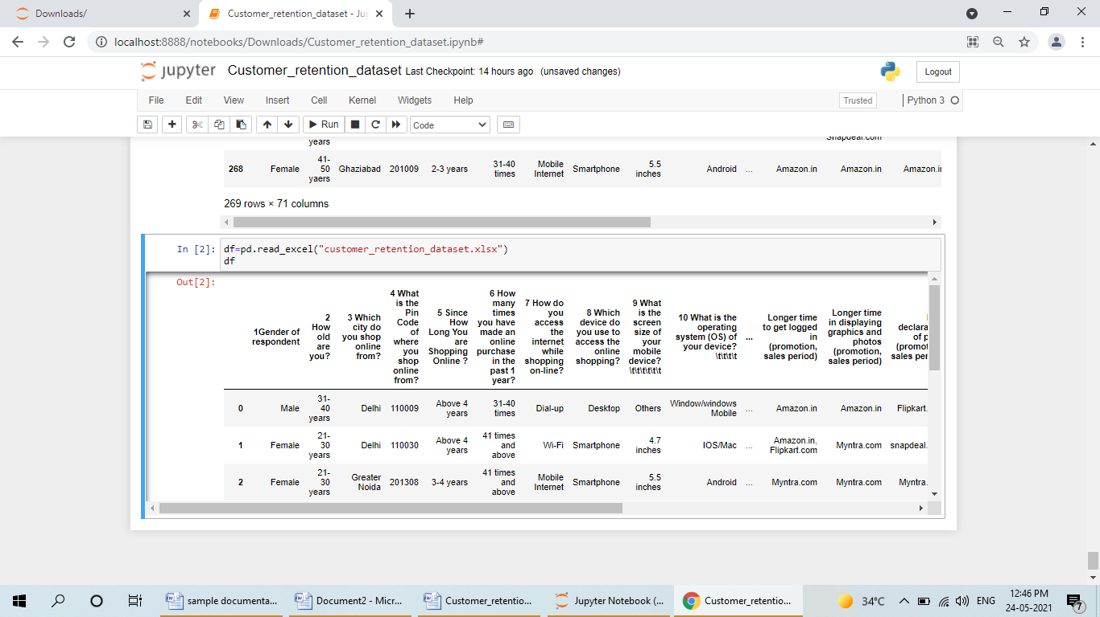

Now we will Understanding the data

#showing some upper columns

**df.head()**

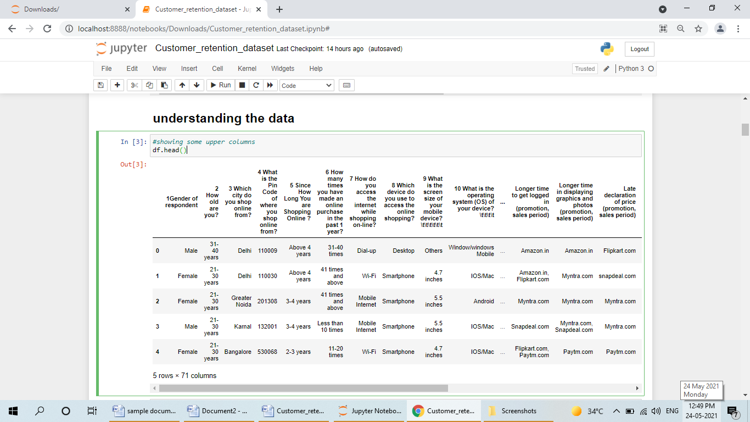

#showing some lower columns

**df.tail()**

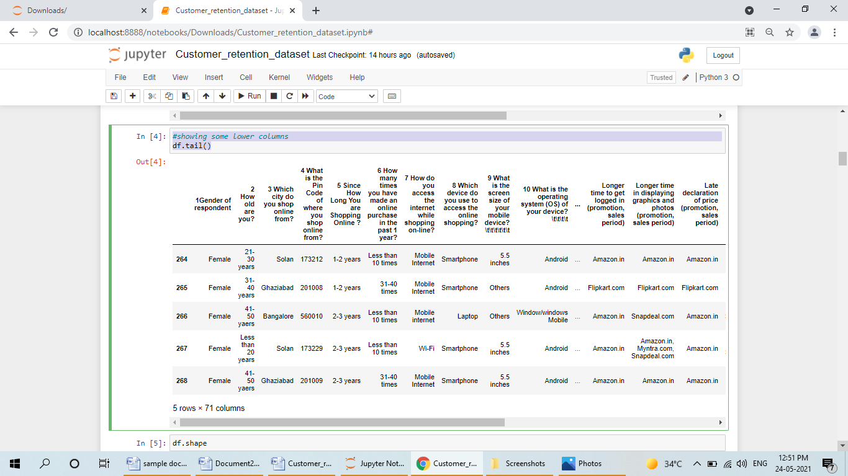

Now we will see the shape of dataset

**df.shape**

(269, 71)

There are 269 rows and 71 Columns in this Dataset.

**df.columns**

Index(['1Gender of respondent', '2 How old are you? ',

'3 Which city do you shop online from?',

'4 What is the Pin Code of where you shop online from?',

'5 Since How Long You are Shopping Online ?',

'6 How many times you have made an online purchase in the past 1 year?',

'7 How do you access the internet while shopping on-line?',

'8 Which device do you use to access the online shopping?',

'9 What is the screen size of your mobile device?\t\t\t\t\t\t ',

'10 What is the operating system (OS) of your device?\t\t\t\t ',

'11 What browser do you run on your device to access the website?\t\t\t ',

'12 Which channel did you follow to arrive at your favorite online store for the first time? ',

'13 After first visit, how do you reach the online retail store?\t\t\t\t ',

'14 How much time do you explore the e- retail store before making a purchase decision? ',

'15 What is your preferred payment Option?\t\t\t\t\t ',

'16 How frequently do you abandon (selecting an items and leaving without making payment) your shopping cart?\t\t\t\t\t\t\t ',

'17 Why did you abandon the “Bag”, “Shopping Cart”?\t\t\t\t\t ',

'18 The content on the website must be easy to read and understand',

'19 Information on similar product to the one highlighted is important for product comparison',

'20 Complete information on listed seller and product being offered is important for purchase decision.',

'21 All relevant information on listed products must be stated clearly',

'22 Ease of navigation in website', '23 Loading and processing speed',

'24 User friendly Interface of the website',

'25 Convenient Payment methods',

'26 Trust that the online retail store will fulfill its part of the transaction at the stipulated time',

'27 Empathy (readiness to assist with queries) towards the customers',

'28 Being able to guarantee the privacy of the customer',

'29 Responsiveness, availability of several communication channels (email, online rep, twitter, phone etc.)',

'30 Online shopping gives monetary benefit and discounts',

'31 Enjoyment is derived from shopping online',

'32 Shopping online is convenient and flexible',

'33 Return and replacement policy of the e-tailer is important for purchase decision',

'34 Gaining access to loyalty programs is a benefit of shopping online',

'35 Displaying quality Information on the website improves satisfaction of customers',

'36 User derive satisfaction while shopping on a good quality website or application',

'37 Net Benefit derived from shopping online can lead to users satisfaction',

'38 User satisfaction cannot exist without trust',

'39 Offering a wide variety of listed product in several category',

'40 Provision of complete and relevant product information',

'41 Monetary savings',

'42 The Convenience of patronizing the online retailer',

'43 Shopping on the website gives you the sense of adventure',

'44 Shopping on your preferred e-tailer enhances your social status',

'45 You feel gratification shopping on your favorite e-tailer',

'46 Shopping on the website helps you fulfill certain roles',

'47 Getting value for money spent',

'From the following, tick any (or all) of the online retailers you have shopped from; ',

'Easy to use website or application',

'Visual appealing web-page layout', 'Wild variety of product on offer',

'Complete, relevant description information of products',

'Fast loading website speed of website and application',

'Reliability of the website or application',

'Quickness to complete purchase',

'Availability of several payment options', 'Speedy order delivery ',

'Privacy of customers’ information',

'Security of customer financial information',

'Perceived Trustworthiness',

'Presence of online assistance through multi-channel',

'Longer time to get logged in (promotion, sales period)',

'Longer time in displaying graphics and photos (promotion, sales period)',

'Late declaration of price (promotion, sales period)',

'Longer page loading time (promotion, sales period)',

'Limited mode of payment on most products (promotion, sales period)',

'Longer delivery period', 'Change in website/Application design',

'Frequent disruption when moving from one page to another',

'Website is as efficient as before',

'Which of the Indian online retailer would you recommend to a friend?'],

dtype='object')

**df.columns.values**

array(['1Gender of respondent', '2 How old are you? ',

'3 Which city do you shop online from?',

'4 What is the Pin Code of where you shop online from?',

'5 Since How Long You are Shopping Online ?',

'6 How many times you have made an online purchase in the past 1 year?',

'7 How do you access the internet while shopping on-line?',

'8 Which device do you use to access the online shopping?',

'9 What is the screen size of your mobile device?\t\t\t\t\t\t ',

'10 What is the operating system (OS) of your device?\t\t\t\t ',

'11 What browser do you run on your device to access the website?\t\t\t ',

'12 Which channel did you follow to arrive at your favorite online store for the first time? ',

'13 After first visit, how do you reach the online retail store?\t\t\t\t ',

'14 How much time do you explore the e- retail store before making a purchase decision? ',

'15 What is your preferred payment Option?\t\t\t\t\t ',

'16 How frequently do you abandon (selecting an items and leaving without making payment) your shopping cart?\t\t\t\t\t\t\t ',

'17 Why did you abandon the “Bag”, “Shopping Cart”?\t\t\t\t\t ',

'18 The content on the website must be easy to read and understand',

'19 Information on similar product to the one highlighted is important for product comparison',

'20 Complete information on listed seller and product being offered is important for purchase decision.',

'21 All relevant information on listed products must be stated clearly',

'22 Ease of navigation in website',

'23 Loading and processing speed',

'24 User friendly Interface of the website',

'25 Convenient Payment methods',

'26 Trust that the online retail store will fulfill its part of the transaction at the stipulated time',

'27 Empathy (readiness to assist with queries) towards the customers',

'28 Being able to guarantee the privacy of the customer',

'29 Responsiveness, availability of several communication channels (email, online rep, twitter, phone etc.)',

'30 Online shopping gives monetary benefit and discounts',

'31 Enjoyment is derived from shopping online',

'32 Shopping online is convenient and flexible',

'33 Return and replacement policy of the e-tailer is important for purchase decision',

'34 Gaining access to loyalty programs is a benefit of shopping online',

'35 Displaying quality Information on the website improves satisfaction of customers',

'36 User derive satisfaction while shopping on a good quality website or application',

'37 Net Benefit derived from shopping online can lead to users satisfaction',

'38 User satisfaction cannot exist without trust',

'39 Offering a wide variety of listed product in several category',

'40 Provision of complete and relevant product information',

'41 Monetary savings',

'42 The Convenience of patronizing the online retailer',

'43 Shopping on the website gives you the sense of adventure',

'44 Shopping on your preferred e-tailer enhances your social status',

'45 You feel gratification shopping on your favorite e-tailer',

'46 Shopping on the website helps you fulfill certain roles',

'47 Getting value for money spent',

'From the following, tick any (or all) of the online retailers you have shopped from; ',

'Easy to use website or application',

'Visual appealing web-page layout',

'Wild variety of product on offer',

'Complete, relevant description information of products',

'Fast loading website speed of website and application',

'Reliability of the website or application',

'Quickness to complete purchase',

'Availability of several payment options',

'Speedy order delivery ', 'Privacy of customers’ information',

'Security of customer financial information',

'Perceived Trustworthiness',

'Presence of online assistance through multi-channel',

'Longer time to get logged in (promotion, sales period)',

'Longer time in displaying graphics and photos (promotion, sales period)',

'Late declaration of price (promotion, sales period)',

'Longer page loading time (promotion, sales period)',

'Limited mode of payment on most products (promotion, sales period)',

'Longer delivery period', 'Change in website/Application design',

'Frequent disruption when moving from one page to another',

'Website is as efficient as before',

'Which of the Indian online retailer would you recommend to a friend?'],

dtype=object)

**df.info()**

<class 'pandas.core.frame.DataFrame'>

RangeIndex: 269 entries, 0 to 268

Data columns (total 71 columns):

# Column Non-Null Count Dtype

--- ------ -------------- -----

0 1Gender of respondent 269 non-null object

1 2 How old are you? 269 non-null object

2 3 Which city do you shop online from? 269 non-null object

3 4 What is the Pin Code of where you shop online from? 269 non-null int64

4 5 Since How Long You are Shopping Online ? 269 non-null object

5 6 How many times you have made an online purchase in the past 1 year? 269 non-null object

6 7 How do you access the internet while shopping on-line? 269 non-null object

7 8 Which device do you use to access the online shopping? 269 non-null object

8 9 What is the screen size of your mobile device? 269 non-null object

9 10 What is the operating system (OS) of your device? 269 non-null object

10 11 What browser do you run on your device to access the website? 269 non-null object

11 12 Which channel did you follow to arrive at your favorite online store for the first time? 269 non-null object

12 13 After first visit, how do you reach the online retail store? 269 non-null object

13 14 How much time do you explore the e- retail store before making a purchase decision? 269 non-null object

14 15 What is your preferred payment Option? 269 non-null object

15 16 How frequently do you abandon (selecting an items and leaving without making payment) your shopping cart? 269 non-null object

16 17 Why did you abandon the “Bag”, “Shopping Cart”? 269 non-null object

17 18 The content on the website must be easy to read and understand 269 non-null object

18 19 Information on similar product to the one highlighted is important for product comparison 269 non-null object

19 20 Complete information on listed seller and product being offered is important for purchase decision. 269 non-null object

20 21 All relevant information on listed products must be stated clearly 269 non-null object

21 22 Ease of navigation in website 269 non-null object

22 23 Loading and processing speed 269 non-null object

23 24 User friendly Interface of the website 269 non-null object

24 25 Convenient Payment methods 269 non-null object

25 26 Trust that the online retail store will fulfill its part of the transaction at the stipulated time 269 non-null object

26 27 Empathy (readiness to assist with queries) towards the customers 269 non-null object

27 28 Being able to guarantee the privacy of the customer 269 non-null object

28 29 Responsiveness, availability of several communication channels (email, online rep, twitter, phone etc.) 269 non-null object

29 30 Online shopping gives monetary benefit and discounts 269 non-null object

30 31 Enjoyment is derived from shopping online 269 non-null object

31 32 Shopping online is convenient and flexible 269 non-null object

32 33 Return and replacement policy of the e-tailer is important for purchase decision 269 non-null object

33 34 Gaining access to loyalty programs is a benefit of shopping online 269 non-null object

34 35 Displaying quality Information on the website improves satisfaction of customers 269 non-null object

35 36 User derive satisfaction while shopping on a good quality website or application 269 non-null object

36 37 Net Benefit derived from shopping online can lead to users satisfaction 269 non-null object

37 38 User satisfaction cannot exist without trust 269 non-null object

38 39 Offering a wide variety of listed product in several category 269 non-null object

39 40 Provision of complete and relevant product information 269 non-null object

40 41 Monetary savings 269 non-null object

41 42 The Convenience of patronizing the online retailer 269 non-null object

42 43 Shopping on the website gives you the sense of adventure 269 non-null object

43 44 Shopping on your preferred e-tailer enhances your social status 269 non-null object

44 45 You feel gratification shopping on your favorite e-tailer 269 non-null object

45 46 Shopping on the website helps you fulfill certain roles 269 non-null object

46 47 Getting value for money spent 269 non-null object

47 From the following, tick any (or all) of the online retailers you have shopped from; 269 non-null object

48 Easy to use website or application 269 non-null object

49 Visual appealing web-page layout 269 non-null object

50 Wild variety of product on offer 269 non-null object

51 Complete, relevant description information of products 269 non-null object

52 Fast loading website speed of website and application 269 non-null object

53 Reliability of the website or application 269 non-null object

54 Quickness to complete purchase 269 non-null object

55 Availability of several payment options 269 non-null object

56 Speedy order delivery 269 non-null object

57 Privacy of customers’ information 269 non-null object

58 Security of customer financial information 269 non-null object

59 Perceived Trustworthiness 269 non-null object

60 Presence of online assistance through multi-channel 269 non-null object

61 Longer time to get logged in (promotion, sales period) 269 non-null object

62 Longer time in displaying graphics and photos (promotion, sales period) 269 non-null object

63 Late declaration of price (promotion, sales period) 269 non-null object

64 Longer page loading time (promotion, sales period) 269 non-null object

65 Limited mode of payment on most products (promotion, sales period) 269 non-null object

66 Longer delivery period 269 non-null object

67 Change in website/Application design 269 non-null object

68 Frequent disruption when moving from one page to another 269 non-null object

69 Website is as efficient as before 269 non-null object

70 Which of the Indian online retailer would you recommend to a friend? 269 non-null object

dtypes: int64(1), object(70)

memory usage: 149.3+ KB

There is in 71 columns, we have 70 object data types and 1 is integer data type.

**SUMMARY STATISTICS**

**df.describe()**

|  | **4 What is the Pin Code of where you shop online from?** |
| --- | --- |
| **count** | 269.000000 |
| **mean** | 220465.747212 |
| **std** | 140524.341051 |
| **min** | 110008.000000 |
| **25%** | 122018.000000 |
| **50%** | 201303.000000 |
| **75%** | 201310.000000 |
| **max** | 560037.000000 |

In this we can see that median is higher than minimum. So our data is not skewed.

The count is 269 as our rows in dataset it means there is no null values.

Now we will understand the data using boxplot.

**df.boxplot()**

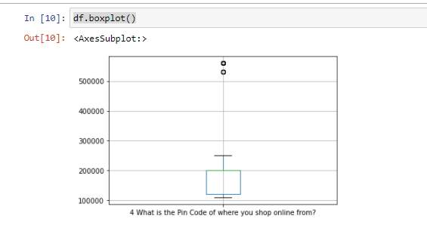

It showing some outliers in boxplot method.

Now we will use the Histogram method

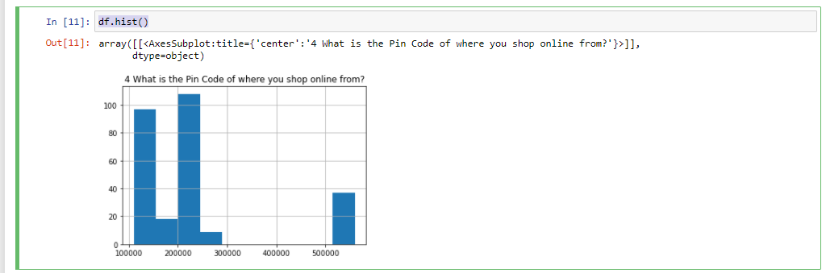

Now will go thru Data cleaning process

**Data Cleaning**

Count the number of missing values in the Dataframe

**Df.isnull()**

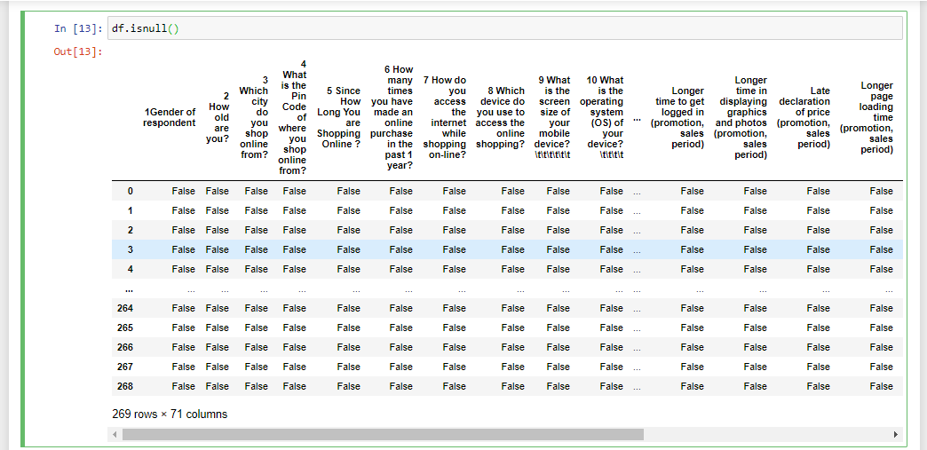

In Large dataset, may b there are some data is missing between the centre columns, so we check it by using another function.

**df.isnull().values.any()**

**False**

#count the number of missing values in each column

**df.isnull().sum()**

1Gender of respondent 0

2 How old are you? 0

3 Which city do you shop online from? 0

4 What is the Pin Code of where you shop online from? 0

5 Since How Long You are Shopping Online ? 0

..

Longer delivery period 0

Change in website/Application design 0

Frequent disruption when moving from one page to another 0

Website is as efficient as before 0

Which of the Indian online retailer would you recommend to a friend? 0

Length: 71, dtype: int64

It shows there are no null values.

Now we will see the null values using heatmap

**sns.heatmap(df.isnull())**

**plt.show()**

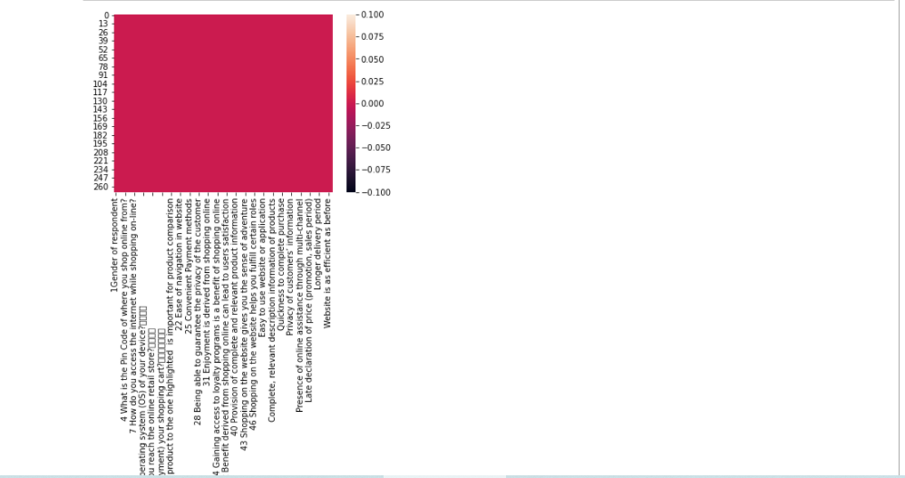

There is no null values in this Dataset.

**This Detailed Data Analysis of Customer Retention Dataset.**

**THANK YOU**